Local publication for call for proposals
Human Rights, Democracy and Civil Society programme for Serbia 2024-2025  EuropeAid/184378/DD/ACT/RS | 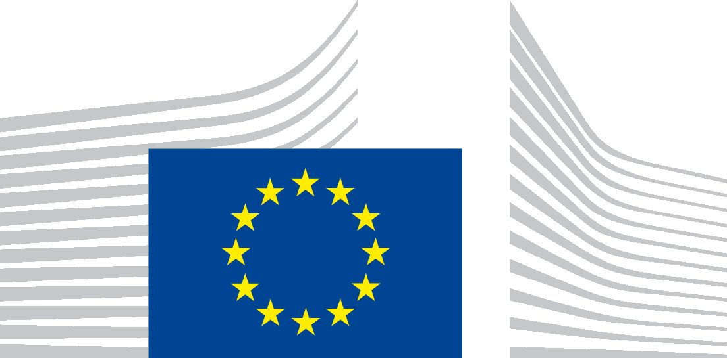
European Commission is seeking proposals for support and strengthening of civil society organisations working on the promotion and protection of: (i) human rights and fundamental freedoms; (ii) the rule of law and justice; and (iii) good governance and democracies and the EU integration and approximation process in Serbia through an enhanced contribution by civil society. The financial assistance will be provided from the Thematic Programme on Human Rights and Democracy and Civil Society Facility - Serbia Country Allocations for 2024 and 2025.
The full guidelines for applicants are available for consultation on the following internet sites:
- https://webgate.ec.europa.eu/online-services/#/
- https://ec.europa.eu/info/funding-tenders/opportunities/portal/screen/opportunities/calls-for-proposals?status=31094501,31094502&frameworkProgramme=111111&order=DESC&pageNumber=1&pageSize=50&sortBy=startDate
- https://eumogucnosti.rs/opportunities/?lang=en
- https://europa.rs/open-calls/?lang=en
The deadline for submission of proposals is 15/07/2025 at 14:00 (Brussels date and time). An information session on this call for proposals will be held online on 11/06/2025 at 10:00 (Brussels date and time).

